Club Cricket Review 2007-08 Season

1. Playing Numbers

 | 91/92 | 92/93 | 93/94 | 94/95 | 95/96 | 96/97 | Total | 00/01 | 01/02 | 02/03 | 03/04 | 04/05 | 05/06 | 06/07 | 07/08
Burnside | 17 | 16 | 18 | 20 | 21 | 20 | 112 | 19 | 17 | 20 | 19 |  |  | 23 | 22 | 120
E/S | 17 | 18 | 21 | 19 | 20 | 17 | 112 | 18 | 17 | 18 | 20 | 18 | 17 | 18 | 18 | 144
HSOB | 20 | 21 | 20 | 23 | 20 | 18 | 122 | 23 | 20 | 20 | 25 |  |  |  |  | 88
LPW | 16 | 18 | 20 | 18 | 22 | 16 | 110 | 20 | 18 | 18 | 19 | 18 | 24 | 24 | 17 | 158
Marist | 17 | 13 | 14 | 17 | 14 | 19 | 94 | 16 | 21 | 21 | 21 |  | 19 | 20 | 22 | 140
Old Coll | 19 | 18 | 18 | 20 | 20 | 18 | 113 | 18 | 18 | 21 | 25 | 28 | 26 | 28 | 30 | 194
Riccarton | 19 | 17 | 16 | 17 | 16 | 18 | 103 | 18 | 16 | 15 | 18 | 18 | 20 | 18 | 23 | 146
St Albans | 17 | 18 | 19 | 22 | 21 | 22 | 119 | 18 | 21 | 18 | 21 | 24 | 24 | 18 | 25 | 169
Sydenham | 20 | 20 | 18 | 24 | 19 | 22 | 123 | 21 | 20 | 19 | 23 | 18 |  | 24 | 20 | 145
Woolston | 18 | 13 | 14 | 14 | 15 | 17 | 91
 | 180 | 172 | 178 | 194 | 188 | 187 |  | 171 | 168 | 170 | 191 | 124 | 130 | 173 | 177
per team | 18 | 17.2 | 17.8 | 19.4 | 18.8 | 18.7 |  | 19 | 18.6 | 18.8 | 21.2 | 20.6 | 21.6 | 21.6 | 22.1

This shows an increase in the number of cricketers playing in the two day competition from an average of 18 per team in 1991/92 to 22 in 2007-08. It is skewed somewhat by the high usage in some clubs such as OBC and St Albans. The more successful clubs use fewer players. The reduction to six senior clubs in 2004-05 and 2005-06 did not reduce the number of players per team in the competition. Is the increase since 1991-92 due to the increasing reluctance to play on Sundays or on public holidays?

2. Two day competition

2.1 Scores over 200 and under 100 as percentage of innings
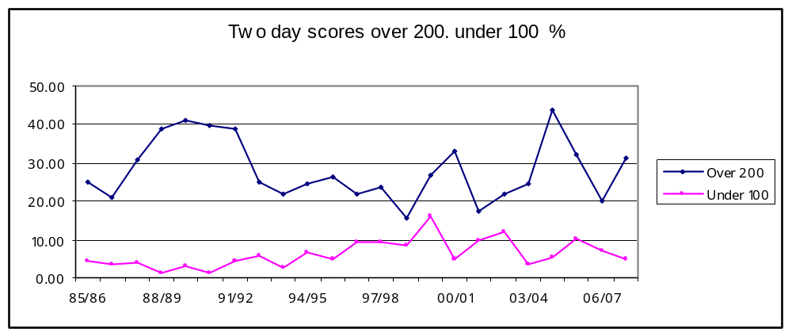
Three of the last four years have seen the number of innings score over 200 almost mirror the high scoring days of the late 1980’s. It is of interest to note that the greatest number of scores over 200 was achieved in the 2004-05 season when the competition was reduced to six teams. The number of scores under 100 has been slowly reducing since the high of the 1999/00 season.

2.2 Results and Declarations as percentage of matches and innings

Results Declarations as %
0.00
10.00
20.00
30.00
40.00
50.00
60.00
70.00
80.00
85/86
89/90
93/94
97/98
01/02
05/06
Results
Declarations
The number of matches that have produced an outright decision, (except for two years 2001/02 and 2002/03), has fallen since
the 1998/99 season. This past season for results and declarations had very similar figures, 42.5% and 36%, and was the closest since the mid 1980’s.
However the previous two seasons had a large variation that was last seen in the 1990’s. Despite a hot summer there were a number of Saturdays this year that were affected by weather and there were 8 declarations in the last round which was unusually high.

3. One day competition

3.1 Scores over 200 and under 100 as a percentage
Scores over 200 under 100 as %
0.00
10.00
20.00
30.00
40.00
50.00
85/86
89/90
93/94
97/98
01/02
05/06
over 200
under 100
Scores over 200 follow similar trends since the 1991/92 season. There is substantial fluctuation over the past 16 years and it is somewhat disappointing that scores have not risen reflecting the trends occurring at first class and International level. Disparity between teams, the quality of pitches, weather and the level of individual performance are some of the factors to consider.

4. Comparison of two and one day competitions.

4.1 Score over 200 compared
Scores over 200 2 day 1 day compared
0.00
10.00
20.00
30.00
40.00
50.00
85/86
88/89
91/92
94/95
97/98
00/01
03/04
06/07
2 day
1 day
In the majority of seasons (13 out of 23) there are more team scores over 200 in the one day competition. This trend is particularly noticeable in the period from 1991/92 (11 out of 16).

4.2 Scores under 100 compared.
Scores under 100 2 day 1 day compared
0.00
3.00
6.00
9.00
12.00
15.00
18.00
85/86
88/89
91/92
94/95
97/98
00/01
03/04
06/07
2 day
1 day
Scores under 100 were more frequent (7 out of 10) in the one day competition between 1985/86 and 1994/95. Since that time no apparent trend emerges with quite noticeable swings between the two competitions.

5. Competition points two day cricket
Competition Points
0
40
80
120
160
200
60/61
65/66
71/72
76/77
81/82
86/87
91/92
96/97
01/02
06/07

Point differential 2 day club cricket
0.00%
20.00%
40.00%
60.00%
80.00%
100.00%
60/61
65/66
71/72
76/77
81/82
86/87
91/92
96/97
01/02
06/07
These two graphs show the points achieved by the first and last team in the two day competition since the 1960/61 season. The lowest difference occurred in the 1970/71 season and the greatest difference in the 1992/93 season. Over the past nine years it is only in the 2006/07 season that the difference was more than 80%.

6. Individual performances

6.1 Centuries in a season
Centuries in a season
15
13
14
13
14
12
8
5
5
13
8
5
13
17
9
7
13
0
3
6
9
12
15
18
1991/92
1994/95
1997/98
2000/01
2003/04
2006/07
Only in five of the last 12 years have there more than 12 centuries scored in a season.

6.2 Batting aggregates
Aggregates in a season
9
2
1
3
1
1
3
0
0
0
1
0
2
4
1
0
2
12
10
10
15
9
2
5
2
0
4
2
3
3
9
3
8
4
0
2
4
6
8
10
12
14
16
1991/92
1994/95
1997/98
2000/01
2003/04
2006/07
500+ runs
400+ runs
A marked reduction since 1995/96 in the number of players scoring more than 400 runs in a season.

6.3 Wickets in as season
Wickets in a season
5
6
2
1
3
5
3
3
5
3
5
3
8
9
6
3
6
6
4
5
6
11
13
10
0
2
4
6
8
10
12
14
1996/97
1998/99
2000/01
2002/03
2004/05
2006/07
over 30 wkts
Over 25 wkts
A marked increase in the number of bowlers taking more than 25 wickets in a season. Is that a reflection in the quality of batting and/or pitches?

